**Initial Design and Prototyping**

**Description:** Develop initial wireframes and prototypes for the succession planning tool. Focus on ease of use and accessibility in the UI design.

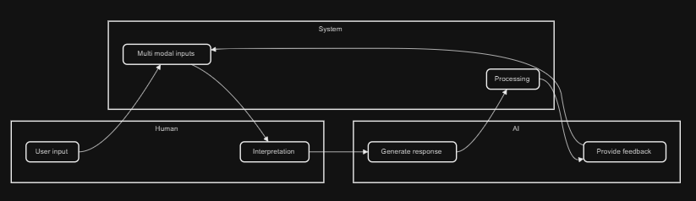

Ease and Accessibility Practices:

1. Intuitive Navigation

* Clear Hierarchy
  + Organize content logically with a clear visual hierarchy to guide users through the interface seamlessly.
* Consistent Layout
  + Maintain consistent layouts and navigation elements across the platform to reduce the learning curve for users.
* Breadcrumbs
  + Use breadcrumb navigation to help users understand their location within the platform and easily navigate back to previous sections.

1. Responsive Design

* Device Adaptability
  + Ensure the UI adapts smoothly to different screen sizes and devices, from desktops to mobile phones.
* Touch-Friendly Elements
  + Design touch-friendly elements, such as larger buttons and interactive areas, for ease of use on mobile devices.

1. Simplified User Interface

* Minimalist Design
  + Keep the design clean and uncluttered, focusing on essential elements to avoid overwhelming users.
* Whitespace Utilization
  + Use whitespace effectively to separate content and make the interface more readable and visually appealing.
* Direct Pathways
  + Provide direct pathways to key actions, minimizing the number of steps required to complete tasks.

1. Accessibility Considerations

* Color Contrast
  + Ensure high color contrast between text and background to make content easily readable for users with visual impairments.
* Keyboard Navigation
  + Design the interface to be fully navigable using a keyboard, catering to users with motor impairments.
* Screen Reader Compatibility
  + Ensure the UI is compatible with screen readers by using appropriate semantic HTML elements and ARIA (Accessible Rich Internet

Design Choices

* Progress Bars
  + Progress bars visually represent the completion status of a process or task.
  + Visually show the progress through the BizBridge platform.
* Carousels:
  + Slideshow for cycling through a series of content
  + Will feature the various sponsors of BizBridge and other products from the site.
* Continuous Videos
  + Continuous videos, or background videos, can add visual interest and engagement to a website.
  + Will demo various website features including some demo conversations with the AIgents.
* Navigation Bar
  + Place common features at the top.